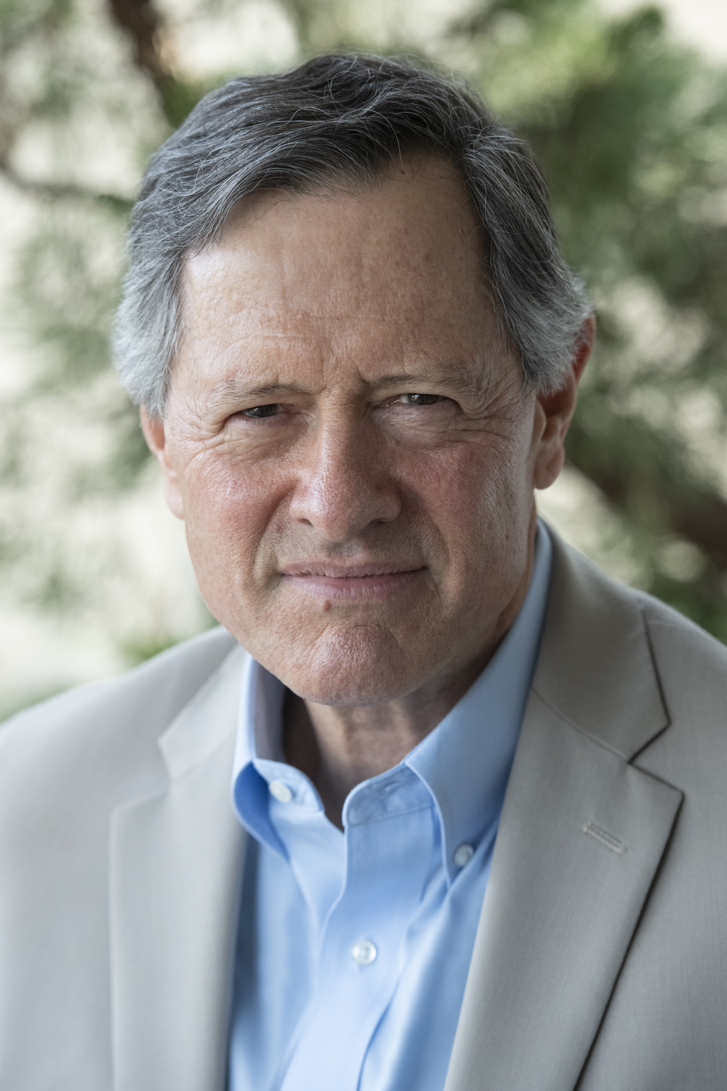  “I created this workshop because I believe we all need to spend more time reflecting on how to find more purpose, meaning, and passion in our lives, and focusing on what really matters to us.” | Design Your Life for Success
 | Email: christopher.n.palmer@gmail.com
 | Phone: 202-716-6160
 | Chris’s website is www.ChrisPalmerOnline.com
This three-part workshop is sponsored by the Bethesda Metro Area Village and by the Connie Morella Library.

It is designed and led by Chris Palmer, a passionate advocate of personal growth. Chris loves helping people achieve success, productivity, and fulfillment.

In addition to being a former professor, he is an author, film producer, speaker, father, and grandfather.

The workshop is open to the public, and it is free. By all means bring a friend!

Please register on line (Click here to register.)

Dates and Location

- Wednesday, April 15, 2020 at 6 to 8 pm: Developing a vision for your stage of life
- Wednesday, April 22, 2020 at 6 to 8 pm: Making your vision operational
- Wednesday, April 29, 2020 at 6 to 8 pm: Taking action and raising your productivity

All classes are at the Connie Morella (Bethesda) Library at 7400 Arlington Road, Bethesda, MD 20814. Phone 240-777-0970. Come to all three sessions if you can.

The workshop is free, but registration is required. Please click here to register. If you have any trouble registering, please email or call Chris Palmer.

Bethesda Metro Area Village is a nonprofit working to help you stay in your home as you age – safely, independently, and in the community you love. We offer volunteer-provided services and robust social programs to enrich the social lives of our members. If you are interested in learning more about membership or how to volunteer, check us out at www.bmavillage.org or call 240-630-2628 or email director@bmavillage.org.

--More--
Workshop Description

The workshop will explore the goals, strategies, and tactics necessary to live a successful, fulfilled, and productive life. We will reflect on our lives, discuss what really matters to us, consider how we find purpose and meaning in our lives, explore our life goals, think about our values, produce personal mission statements, examine how to take better care of ourselves, and learn effective time management skills.

The workshop will focus on the following types of questions:

- What are my goals? How can I bring more purpose, focus, and meaning to my life? What is the best way for me to shape the person I want to become so I can contribute in a meaningful way to society and helping other people?

- Is there a dissonance between how I spend my time and what is most important to me?

- How can I take better care of myself (physically, mentally, spiritually, socially, and emotionally)?

- What is the best way to draft a powerful and inspiring personal mission statement, so that I can begin to see my life in a fresh, focused, and revitalized way?

- What do the words success, happiness, and fulfillment mean? How are they distinct?

- What are the best ways of integrating the vision I have for my life, the plan I need to achieve it, and the actions to make things happen?

- What are the benefits of taking more risks and getting outside my comfort zone?

This workshop is about actively designing our lives rather than simply drifting forward reacting to what happens to us. It is important to periodically sit back, quietly reflect, and ask if our lives are headed in the right direction. It is healthy to look at the person we have become and ask if this is really who we want to be. We should proactively shape our character, decide our future, and create a rewarding life of meaning and purpose.

We want to behave in ways that are true to our most honorable, generous, and best selves. This workshop gives you the chance to design and shape the kind of person you want to be and to articulate the goals you want to achieve in your life, both professionally and personally.

Delivery
This workshop consists of three two-hour discussion sessions on three consecutive Wednesday evenings. We will strive for class sessions that are interactive, lively, engaging, creative, and fun.

--More--
The workshop will be discussion-based and often involve working on your own quietly thinking and writing, or working in pairs or small groups.

Workshop Learning Outcomes
By the end of the workshop, you will be able to:

- Formulate what really matters to you and what values are important to you.

- Create and develop a personal mission statement that reflects the best possible life you want to lead, a life that is passionate, honorable, focused, purposeful, and meaningful.

- Include in your personal mission statements changes you plan to make to your life to bring it into closer alignment with your life goals.

- Apply essential time management skills to your life.

How the Workshop is Taught
I will encourage an active learning environment. Please bring a notebook to class, so you can write and take notes. The room we are using does not contain desks or tables to write on.

For homework, the class may read excerpts from books by Tara Mohr, Jane McGonigal, Edith Hall, Carol Dweck, Julia Cameron, Martin Seligman, Laura Roser, Irvin Yalom, Emily Esfahani Smith, Stephen Covey, Marie Kondo, David Allen, Ben Franklin, and Victor Frankl.

Instructor’s Bio

Chris Palmer is a teacher, speaker, author, and environmental film producer. He served on American University’s full-time faculty as a professor and as Distinguished Film Producer in Residence until his retirement in 2018. In 2004, he founded AU’s Center for Environmental Filmmaking at the School of Communication. Over the past thirty years, Chris has spearheaded the production of more than 300 hours of original programming for primetime television and the IMAX film industry.

He has written five books: Shooting in the Wild: An Insider’s Account of Making Movies in the Animal Kingdom (Sierra Club Books, 2010); Confessions of a Wildlife Filmmaker: The Challenges of Staying Honest in an Industry Where Ratings Are King (Bluefield Publishing, 2015); Raise Your Kids to Succeed: What Every Parent Should Know (Rowman & Littlefield, 2017); Now What, Grad? Your Path to Success after College 2nd Edition (Rowman & Littlefield, 2018); College Teaching at its Best: Inspiring Students to be Enthusiastic, Lifelong Learners (Rowman & Littlefield, 2019). His website is www.ChrisPalmerOnline.com.

* * * * *

Thank you for your interest in the workshop!
Please call me if you have questions. My cell is 202-716-6160.

